Task 1 – System Architecture Planning
1. Introduction:
This project focuses on designing an adaptive traffic control system for two 4-way traffic junctions, referred to as Junction A and Junction B. The two junctions are designed to work together instead of operating independently.
The system provides normal North-South and East-West traffic signal control while also including a green-wave mechanism to coordinate the North-South traffic flow between the two junctions. A shared pedestrian arbiter is used to handle pedestrian requests from both junctions fairly and prevent starvation. In addition, an emergency override mechanism is included to safely transition both junctions to an all-red state when an emergency occurs.
The purpose of this task is to plan the complete system architecture, define the modules and their interfaces, establish the clocking and reset strategy, and prepare a verification plan before RTL/Verilog implementation begins.
2. System Architecture:
The proposed traffic control system consists of two 4-way traffic junctions, Junction A and Junction B. Both junctions operate using a common system clock and are coordinated by additional control modules.
The main modules of the system are:
- Junction A Controller – Controls the traffic signals at Junction A.
- Junction B Controller – Controls the traffic signals at Junction B.
- Green-Wave Controller – Coordinates the North-South green signals of Junction A and Junction B.
- Shared Pedestrian Arbiter – Receives pedestrian requests from both junctions and decides which request should be served first.
- Emergency Controller – Handles the emergency override and ensures that both junctions safely transition to an all-red state.
- Timing Controller – Provides timing information required for traffic signal phase changes.
- Top-Level Controller – Connects all modules and manages the overall system.
The system uses a single common clock domain so that all modules operate synchronously. A synchronous reset is used to initialize the system into a safe all-red state.
The two junction controllers perform normal traffic signal sequencing between North-South and East-West directions. The green-wave controller coordinates the two junctions to improve traffic flow. The shared pedestrian arbiter provides fair access to pedestrian requests from both junctions, while the emergency controller can override normal operation when an emergency is detected.
3. Top-Level Block Diagram:
The following block diagram represents the overall architecture of the adaptive traffic control system. It shows the two traffic junction controllers and the supporting modules used for green-wave coordination, pedestrian arbitration, timing, and emergency control.
Figure 1: Top-Level Architecture of the Adaptive Traffic Control System

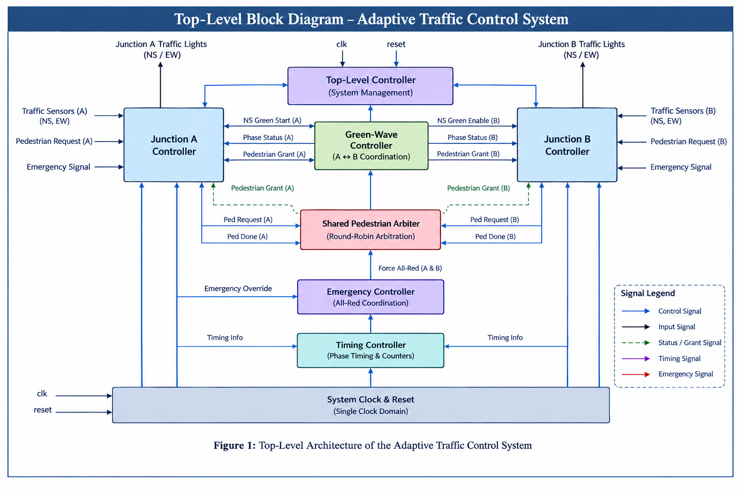
4.1 Junction Controller:
The Junction Controller is responsible for controlling the traffic signals of one 4-way junction. The same controller architecture is used for both Junction A and Junction B. It controls the North-South and East-West traffic phases and responds to pedestrian, green-wave, timing, reset, and emergency control signals.
Inputs:
Signal | Description
clk | Common system clock
reset | Synchronous reset signal
emergency_override | Requests emergency operation
wave_enable | Green-wave coordination signal
ped_grant | Permission to serve a pedestrian request
phase_timer_done | Indicates that the current traffic phase has completed
Outputs:
Signal | Description
ns_red | North-South red signal
ns_yellow | North-South yellow signal
ns_green | North-South green signal
ew_red | East-West red signal
ew_yellow | East-West yellow signal
ew_green | East-West green signal
ns_green_start | Indicates the beginning of the North-South green phase
ped_active | Indicates that pedestrian service is active
all_red | Indicates that the junction is in the all-red state
Purpose
The Junction Controller implements the normal traffic signal sequence between North-South and East-West traffic. It also responds to green-wave coordination, pedestrian grants, and emergency commands while maintaining safe traffic signal states.
4.2 Green-Wave Controller:
The Green-Wave Controller coordinates the North-South traffic phases of Junction A and Junction B. Its main purpose is to ensure that Junction B starts its North-South green phase within a defined delay after Junction A starts its North-South green phase.
Inputs:
Signal | Description
clk | Common system clock
reset | Synchronous reset signal
a_ns_green_start | Indicates that Junction A has started its North-South green phase
b_ready | Indicates that Junction B is ready for the coordinated North-South phase
emergency_override | Indicates that emergency operation is active
Outputs:
Signal | Description
b_ns_green_enable | Allows Junction B to start its North-South green phase
wave_active | Indicates that green-wave coordination is currently active
Design Parameter
Parameter | Value | Description
GREEN_WAVE_DELAY | 5 clock cycles | Maximum coordination delay between Junction A and Junction B
Operation:
When a_ns_green_start becomes active, the Green-Wave Controller starts a delay counter. After the defined delay, it generates b_ns_green_enable for Junction B, provided that Junction B is ready and no emergency condition is active.
This coordination allows vehicles travelling in the North-South direction to experience a more continuous flow between the two junctions.
4.3 Shared Pedestrian Arbiter:
The Shared Pedestrian Arbiter manages pedestrian requests from both Junction A and Junction B. Instead of using separate pedestrian controllers for each junction, a single arbiter is used to make a centralized and fair decision.
The arbiter uses a round-robin arbitration scheme to prevent starvation when both junctions request pedestrian service at the same time.
Inputs:
Signal | Description
clk | Common system clock
reset | Synchronous reset signal
ped_req_A | Pedestrian request from Junction A
ped_req_B | Pedestrian request from Junction B
ped_done_A | Indicates completion of pedestrian service at Junction A
ped_done_B | Indicates completion of pedestrian service at Junction B
emergency_override | Indicates that emergency operation is active
Outputs:
Signal |  | Description
ped_grant_A |  | Grants pedestrian service to Junction A
ped_grant_B |  | Grants pedestrian service to Junction B
arbiter_busy |  | Indicates that a pedestrian request is currently being served
Arbitration Method:
The arbiter uses round-robin priority. When only one junction requests pedestrian service, that request is granted. When both junctions request service simultaneously, the arbiter grants the request according to the current priority.
After a request has been successfully served, the priority changes to the other junction. This ensures that repeated simultaneous requests are handled fairly.
Starvation Prevention:
The round-robin mechanism prevents starvation by alternating the priority between Junction A and Junction B. Therefore, if both junctions continuously generate pedestrian requests, neither junction can be continuously denied service.
During emergency operation, normal pedestrian arbitration is suspended so that both traffic junctions can safely transition to the required all-red state.
4.4 Emergency Controller:
The Emergency Controller manages the emergency override condition for the complete traffic control system. A single emergency input is used to override normal traffic operation and safely transition both Junction A and Junction B to the all-red state.
Inputs:
Signal | Description
clk | Common system clock
reset | Synchronous reset signal
emergency_override | Activates emergency operation
a_all_red | Indicates that Junction A has reached the all-red state
b_all_red | Indicates that Junction B has reached the all-red state
Outputs:
Signal | Description
emergency_active | Indicates that the system is operating in emergency mode
force_all_red | Commands both junction controllers to enter the all-red state
emergency_complete | Indicates that both junctions have reached the all-red state
Emergency Response Requirement:
When emergency_override is activated, normal traffic sequencing and green-wave coordination are overridden. The Emergency Controller commands both junctions to transition safely to the all-red state.
The maximum emergency response time is defined as 3 clock cycles. Therefore, both Junction A and Junction B must reach the all-red state within three clock cycles after the emergency condition is detected.
Safe State:
During emergency operation:
- Junction A: North-South = RED, East-West = RED
- Junction B: North-South = RED, East-West = RED
- Normal green-wave coordination is suspended.
- New pedestrian requests are not granted until emergency operation is cleared.
4.5 Timing Controller:
The Timing Controller provides timing information for the traffic signal phases. It determines when the current phase has completed and allows the Junction Controllers to safely move to the next phase.
Inputs:
- clk – Common system clock.
- reset – Synchronous reset signal.
- timer_enable – Enables the timer.
- phase_select – Selects the current traffic-light phase.
Outputs:
- phase_timer_done – Indicates that the selected phase duration has been completed.
- timer_value – Provides the current timer count.
Purpose:
The Timing Controller ensures that each traffic phase remains active for its required duration. It is shared logically across the system and provides consistent timing information to both Junction A and Junction B. The timing values can be configured as design parameters, making the system easier to modify and verify.
4.6 Top-Level Controller:
The Top-Level Controller connects all the major modules of the traffic control system. It manages the communication between the two Junction Controllers, Green-Wave Controller, Shared Pedestrian Arbiter, Emergency Controller, and Timing Controller.
Inputs:
- clk – Common system clock.
- reset – Synchronous reset signal.
- ped_req_A – Pedestrian request from Junction A.
- ped_req_B – Pedestrian request from Junction B.
- emergency_override – Emergency override request.
Outputs:
- junction_A_signals – Traffic signals for Junction A.
- junction_B_signals – Traffic signals for Junction B.
- ped_grant_A – Pedestrian grant for Junction A.
- ped_grant_B – Pedestrian grant for Junction B.
- emergency_active – Indicates that emergency mode is active.
Purpose:
The Top-Level Controller provides the overall system connectivity and ensures that all modules operate together correctly. It distributes the common clock and reset signals and routes control and status signals between the modules. This modular structure makes the design easier to understand, implement, test, and modify.
5. Green-Wave Mechanism:
The Green-Wave Mechanism is used to coordinate the North-South (NS) traffic flow between Junction A and Junction B. Its purpose is to allow vehicles travelling in the NS direction to pass through both junctions with reduced stopping.
When the NS green phase begins at Junction A, the Green-Wave Controller starts a delay counter. After the configured delay, it sends an enable signal to Junction B to begin its NS green phase, provided that Junction B is in a safe and ready state.
For this design, the green-wave delay is set as a configurable parameter of 5 clock cycles.
Operation:
- Junction A starts its NS green phase.
- Junction A generates the a_ns_green_start signal.
- The Green-Wave Controller starts counting the configured delay.
- After 5 clock cycles, the controller checks whether Junction B is ready.
- If Junction B is ready and no emergency is active, b_ns_green_enable is generated.
- Junction B starts its NS green phase.
- During emergency operation, the green-wave mechanism is disabled.
This mechanism improves coordination between the two junctions while maintaining safe traffic-signal transitions.
6. Shared Pedestrian Arbiter:
The Shared Pedestrian Arbiter manages pedestrian crossing requests from both Junction A and Junction B. Instead of using separate arbitration logic, a single shared arbiter is used to provide fair access to pedestrians at both junctions.
The arbiter uses a round-robin priority mechanism. When only one junction requests pedestrian service, that request is granted. When both junctions request service at the same time, the arbiter grants permission to the junction having the current priority.
After a pedestrian request is successfully served, the priority is changed to the other junction. This ensures that repeated requests from one junction cannot continuously block requests from the other junction.
Operation:
- The arbiter receives ped_req_A and ped_req_B.
- If only one request is active, that request is granted.
- If both requests are active, the current round-robin priority is selected.
- Only one pedestrian grant is active at a time.
- After the selected request is completed, priority switches to the other junction.
- During emergency operation, new pedestrian grants are suspended.
- Pending requests can be served after normal operation resumes.
This architecture provides fairness, controlled access, and starvation prevention while keeping the pedestrian control logic centralized and modular.
7. Clock, Reset & Emergency:
7.1 Clocking Strategy:
The complete traffic control system operates using a single common clock domain. The same clk signal is supplied to Junction A, Junction B, the Green-Wave Controller, Shared Pedestrian Arbiter, Emergency Controller, and Timing Controller.
Using a single clock domain simplifies synchronization and reduces the possibility of timing-related problems between modules.
7.2 Reset Strategy:
A synchronous active-high reset is used for the system.
When reset is asserted, all controllers are returned to their initial safe states. Both Junction A and Junction B are placed in the all-red state.
The reset operation ensures that the system starts from a known and safe condition.
7.3 Emergency Operation:
The system includes a single emergency_override input that is monitored by the Emergency Controller.
When an emergency is detected:
- Normal traffic sequencing is immediately overridden.
- The Green-Wave Controller is disabled.
- New pedestrian grants are suspended.
- Both Junction Controllers are commanded to transition to all-red.
- Both junctions must reach the all-red state within 3 clock cycles.
- Normal operation resumes only after the emergency condition is cleared.
The all-red state ensures that conflicting traffic movements are stopped before the emergency operation proceeds.
7.4 Safe-State Requirements:
During emergency operation:
- Junction A must have all traffic signals red.
- Junction B must have all traffic signals red.
- No North-South or East-West green signal is allowed.
- Green-wave coordination must remain disabled.
- New pedestrian requests must not receive a grant.
8. Verification Plan:
The traffic control system will be verified using simulation-based test scenarios. The verification process will check normal traffic operation, green-wave coordination, pedestrian fairness, emergency response, reset behavior, and overall safety.
The following scenarios will be verified:
No. | Verification Scenario | Expected Result
1 | System reset | Both junctions enter all-red state.
2 | Normal operation of Junction A | NS and EW phases operate in the correct sequence.
3 | Normal operation of Junction B | NS and EW phases operate in the correct sequence.
4 | Long-duration normal operation | No illegal traffic-signal combinations occur.
5 | Start of A NS green | Green-wave controller detects the event.
6 | Green-wave delay | B NS green starts after the configured delay.
7 | Green-wave safety | B does not turn NS green before its safe transition.
8 | Green-wave during emergency | Green-wave operation is disabled.
9 | Pedestrian request at A | A receives the pedestrian grant.
10 | Pedestrian request at B | B receives the pedestrian grant.
11 | Simultaneous pedestrian requests | Only one junction receives the grant at a time.
12 | Repeated simultaneous requests | Round-robin arbitration prevents starvation.
13 | Request while arbiter is busy | Waiting request is served after the current request.
14 | Emergency during pedestrian service | Emergency operation overrides pedestrian service safely.
15 | Emergency during NS green | Junction transitions to all-red.
16 | Emergency during EW green | Junction transitions to all-red.
17 | Emergency during yellow | Junction transitions safely to all-red.
18 | Emergency during all-red | Junction remains in the safe all-red state.
19 | Reset during normal operation | System returns to the initial all-red state.
20 | Long-duration combined operation | No illegal states, starvation, or timing violations occur.
8.1 Key Safety Checks:
The following safety properties will also be checked during verification:
- NS green and EW green must never be active simultaneously at the same junction.
- Both junctions must reach all-red within the specified emergency response time.
- Both pedestrian grants must never be active simultaneously.
- Pedestrian requests must not experience starvation.
- Junction B's NS green must follow the configured green-wave delay after Junction A's NS green start.
- Green-wave operation must remain disabled during emergency mode.
The verification plan ensures that the proposed architecture satisfies the functional, timing, fairness, and safety requirements before RTL implementation.
9. Conclusion
The proposed adaptive traffic control system provides a modular architecture for coordinating two 4-way traffic junctions. The design supports normal traffic sequencing, green-wave coordination between Junction A and Junction B, fair pedestrian request handling, and emergency all-red operation.
The use of separate controllers for traffic signals, green-wave coordination, pedestrian arbitration, timing, and emergency handling improves the modularity and maintainability of the system. A single clock domain and synchronous reset provide a simple and predictable control structure.
The verification plan covers normal operation, timing requirements, pedestrian fairness, emergency response, reset behavior, and important safety conditions. This architecture provides a suitable foundation for the next stage of RTL/Verilog implementation.

